Create a React Application named “ticketbookingapp” where the guest user can browse the page where the flight details are displayed whereas the logged in user only can book tickets.

The Login and Logout buttons should accordingly display different pages. Once the user is logged in the User page should be displayed. When the user clicks on Logout, the Guest page should be displayed.

LoginButton.js

function LoginButton(props){

    return(

        <button onClick={props.onClick}>

            Login

        </button>

    );

}

export default LoginButton;

LogoutButton.js

function LogoutButton(props){

    return(

        <button onClick={props.onClick}>

            Logout

        </button>

    );

}

export default LogoutButton;

Greeting.js

import UserPage from './UserPage';

import GuestPage from './GuestPage';

function Greeting(props){

    const isLoggedIn=props.isLoggedIn;

    if(isLoggedIn){

        return <UserPage />

    }

    return <GuestPage />

}

export default Greeting;

UserPage.js

function UserPage(){

  return(

    <div>

        <h1>Welcome Back</h1>

    </div>

  );

}

export default UserPage;

GuestPage.js

function GuestPage(){

    return(

        <div>

            <h1>Please Sign Up.</h1>

        </div>

    );

}

export default GuestPage;

Execution of the Code:

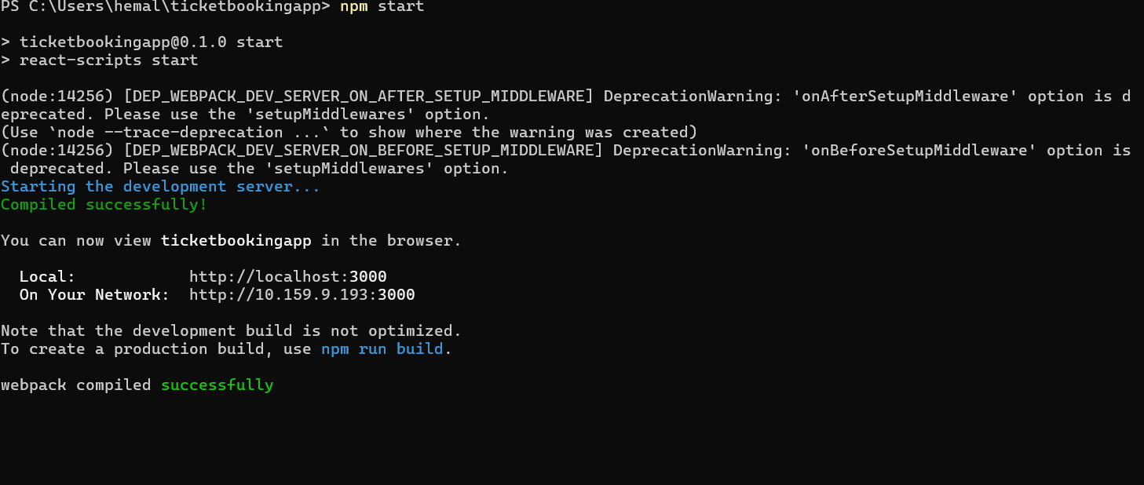

OutPut:

